Upload Sales Office - ITR_SO not possible. Only Address Upload

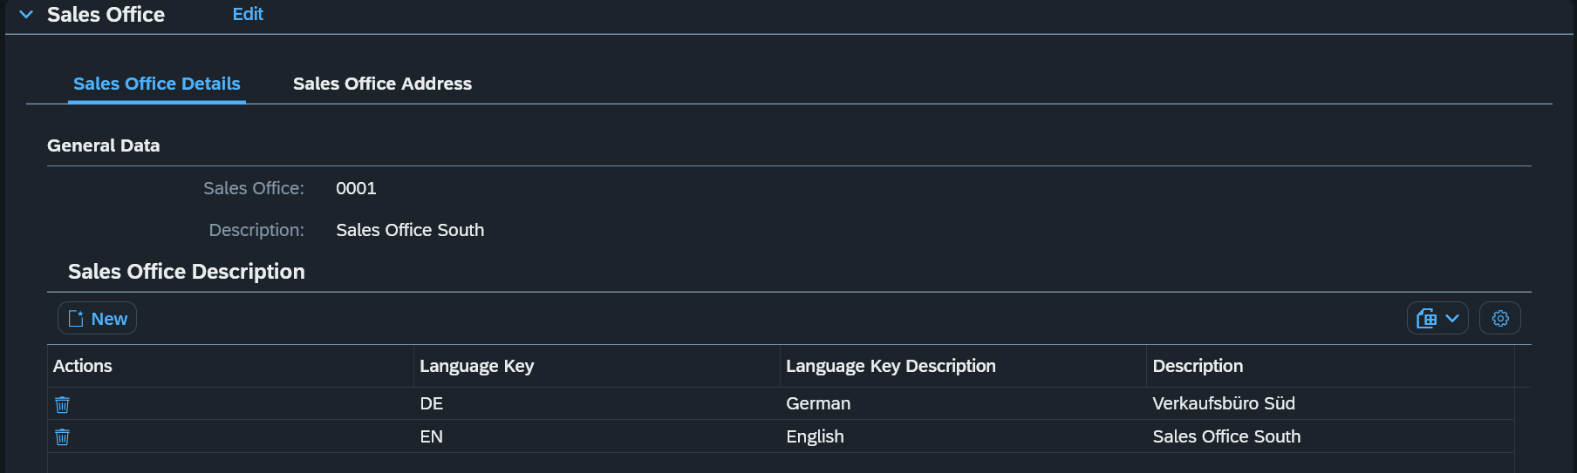

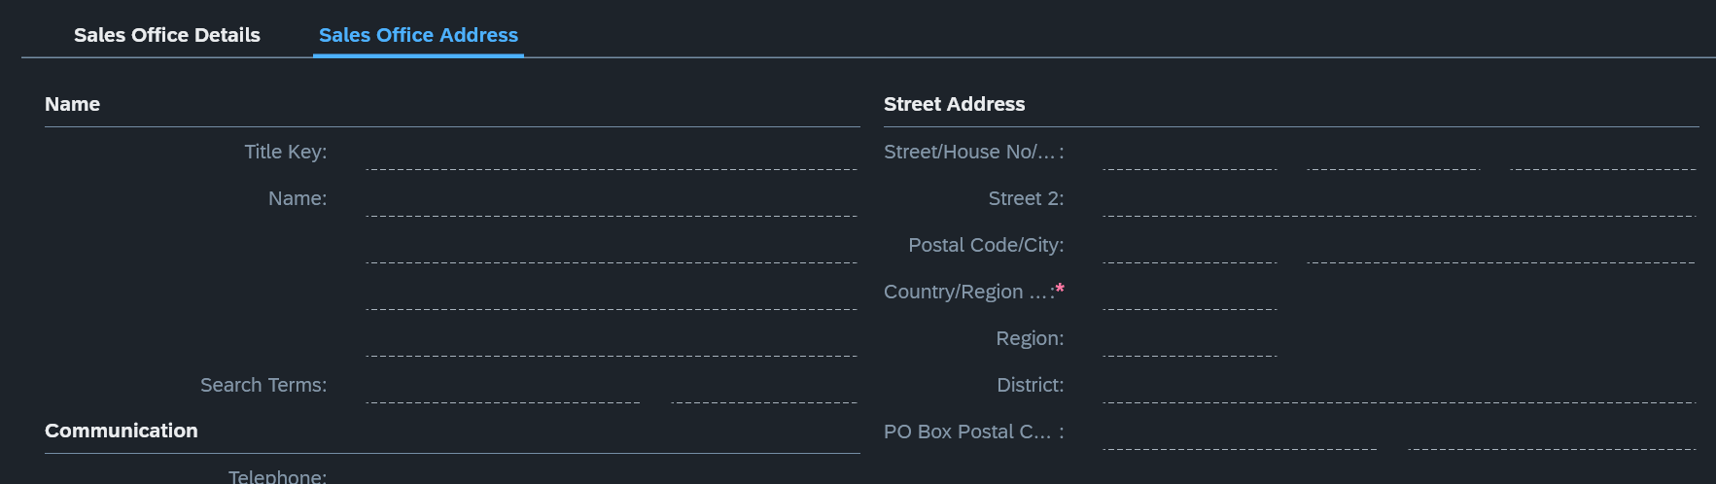

Field Country need to be maintained
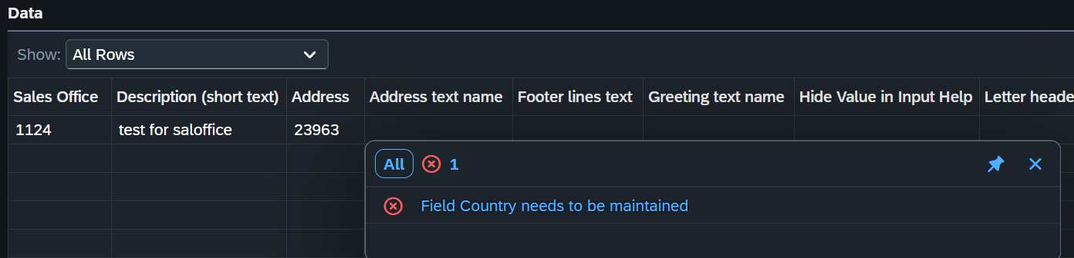
Upload address first is possible, but so upload still not possible
